**Name: Victoria Jacqueline Macías Pico**

**W O R K S H E E T S**

**NOTE:** **Your answers must be in blue and bold.**

# UNIT 11



**1.Write the past participle of the following verbs:**

|  |  |  |  |  |  |
| --- | --- | --- | --- | --- | --- |
| STRUCTURE |  |  |  |  |  |
| (+) | I | have | been | working | since 5 am. |
| (-) | I | Have not | Been | working | Since 5am. |
| (?) | How long | have | you | been | Working? |
| A | Yes, | I have. |  | No, | I haven’t. |

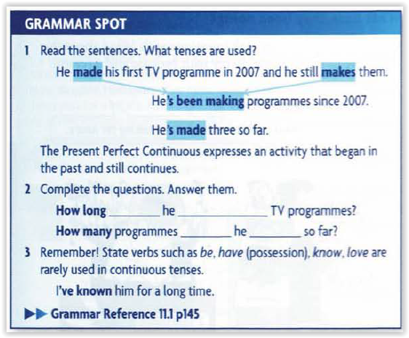

**Has**

**Been making**

**Has**

**made**

**2. Put the verbs into the correct form of PRESENT PERFECT CONTINUOUS. (+)**

1. He  **has been working**  (work) in this company since 1999.
2. I  **have been waiting** (wait) for you since 5 o'clock.
3. Lily  **has been living**  (live) in Colombia since 2010.
4. How long  **have you been learning**  (learn / you) English?

**3. Use the words below to form PRESENT PERFECT CONTINUOUS tense sentences.**

**Examples:** You / run / in the park. **🡪** You've been running in the park.

|  |  |
| --- | --- |
|  | **PRESENT PERFECT CONTINUOUS** |
| 1. She / sit / on the chair all day long. | **She has been sitting on the chair all day long** |
| 1. It / rain / all day | **It has been raining all day** |
| 1. I / work / at the bank | **I have been working at the bank** |
| 1. They / feel / sick since Tuesday | **They have been feeling sick since tuesday** |

**4. Write the verbs in the correct form of PRESENT PERFECT CONTINUOUS. (-)**

1. Luccas  **hasn’t been reading**  his comic book. (not/to read)
2. I  **haven’t been driving**  for two months now. (not/to drive)
3. It  **hasn’t been raining**  much in this area. (not/to rain)
4. Marie  **hasn’t writing**  in her diary. (not/to write)

**5. Make questions using the correct form of PRESENT PERFECT CONTINUOUS. (?)**

1. **Has she been walking**  the whole morning? (she/to walk)
2. Who  **has been digging**  in the garden? (to dig)
3. How long  **have you been wearing**  this ring? (you/to wear)
4. What  **have we been doing**  this whole time? (we/to do)
5. How long  **has they been learning**  French? (they/to learn)

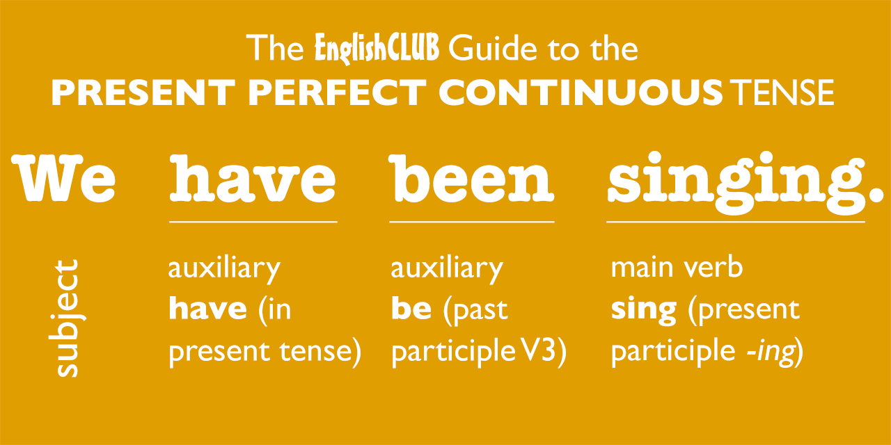

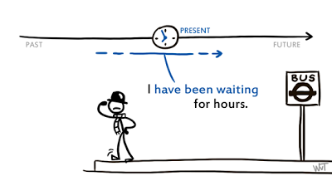

**6. When do we use PRESENT PERFECT and when PRESENT PERFECT CONTINUOUS?**

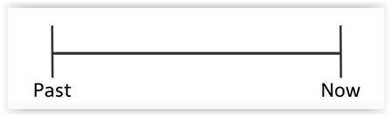

|  |  |  |
| --- | --- | --- |
|  | **PRESENT PERFECT** | **PRESENT PERFECT CONTINUOUS** |
| **Structure** | **S + have/has + verbo PP** | **S+have/has+been+VerboP** |
|  | **To talk about the past, we don’t really know when** | **Action that started in the past and continue in the future or an activity that began in the past and still continues.** |
|  | **To talk about repetead actions** | **To talk about past actions that just ended** |
| **Have**  **hAVE**  **Have**  **Have**  **Has**  **know**  **come**  **using**  **using** | **To talk about sth that started in the past and continuos in the present** | **To talk about an action that started in the past and may have recently ended** |

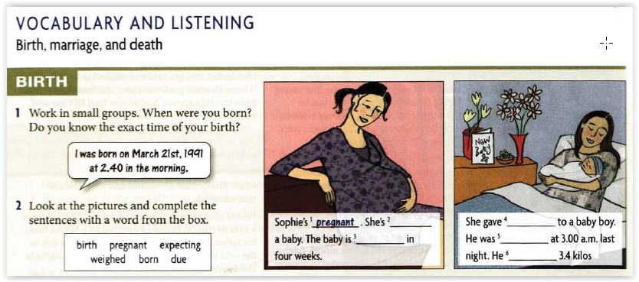

**expecting**

**Due**

**birth**

**born**

**He**

**weighed**

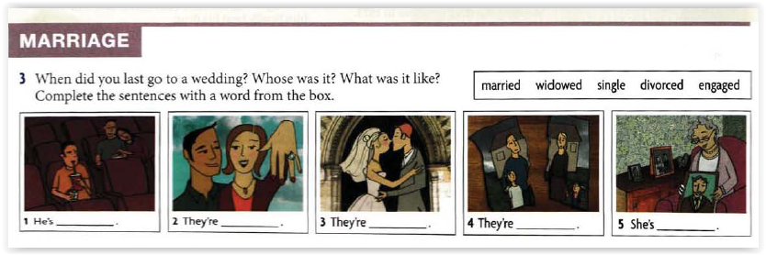

**Single**

**Engaged**

**Married**

**Divorced**

**Windowed**

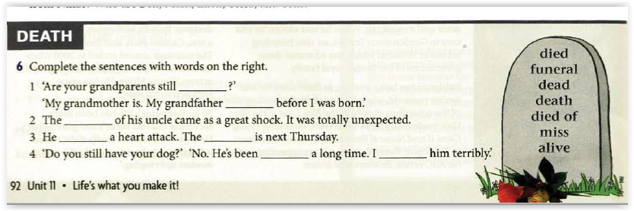

**Alive**

**Died**

**Death**

**Died of**

**Funeral**

**Dead**

**Miss**

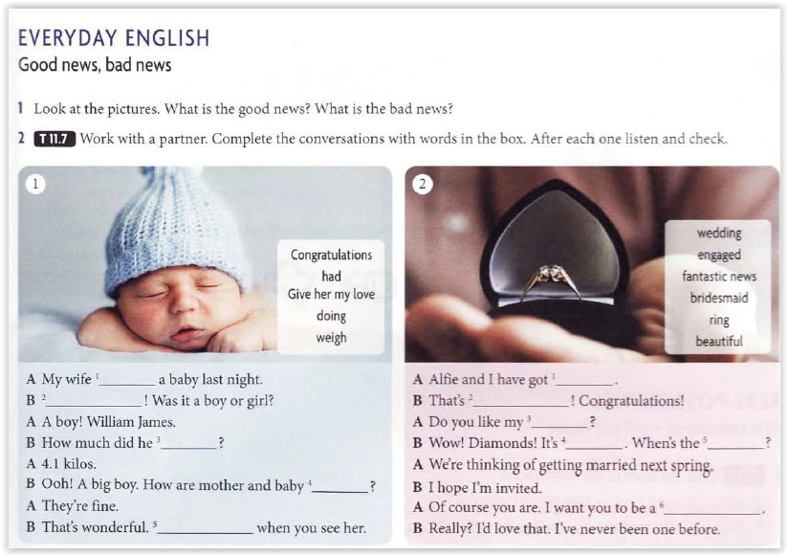

**Had**

**Congratulations**

**Weigh**

**Doing**

**Dive her my love**

**Engaged**

**Fantastic new**

**D**

**Ring**

**Beautiful**

**wedding**

**Bridesmaid**

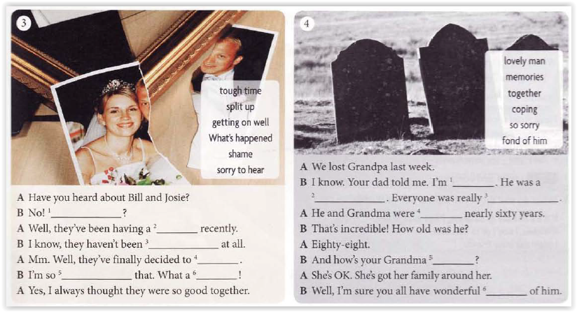

**What’s happened**

**Tough time**

**Getting on well**

**Split up**

**shame**

**Sorry to hear**

**Lovely man**

**Fond of him**

**So sorry**

**together**

**coping**

**memories**